# **Cloud Computing**

# **Definition :** Cloud computing means storing and accessing the data and programs on remote servers that are hosted on the internet instead of the computer’s hard drive or local server. Cloud computing is also referred to as Internet-based computing.

* To more clarification about how cloud computing has changed the commercial deployment of the system. Consider the below examples:

1. **Amazon Web Services (AWS):**One of the most successful cloud-based businesses is Amazon Web Services (AWS), which is an Infrastructure as a Service (Iaas) offering that pays rent for virtual computers on Amazon’s infrastructure.
2. **Microsoft Azure Platform**: Microsoft is creating the Azure platform which enables the .NET Framework Application to run over the internet as an alternative platform for Microsoft developers. This is the classic Platform as a Service (PaaS).
3. **Google:**Google has built a worldwide network of data centers to service its search engine. From this service, Google has captured the world’s advertising revenue. By using that revenue, Google offers free software to users based on infrastructure. This is called Software as a Service (SaaS).

**Amazon Web Services (AWS):**

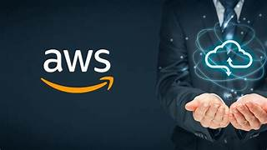

* AWS (Amazon Web Services) is a cloud computing platform.
* The first product (S3) was released in 2006.
* AWS has grown a lot since then in both size and product range.
* It is, to date, the largest cloud provider in the world.

## **The Client-Server Model**

* The client-server model is an important concept in cloud computing.
* It is about many clients using services from a centralized server.

## **What is the Client-Server Model?**

* The Client-Server model is about a client that interacts and makes requests to a computer server.
* A client is the way that the person interact with the server.

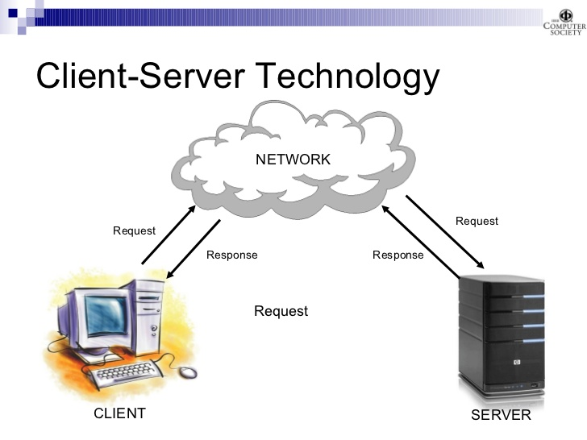

## **Deployment Models**

There are three different kinds of deployment models:

* Cloud-based
* On-premises
* Hybrid

The models are different ways of accessing compute services - over the internet, locally, or in a combination.

## **Cloud-Based Deployment**

* Everything runs in the cloud.
* This model allows you to build new applications or move existing ones to the cloud.
* There are different levels of services ranging from low to high.
* The level of service has different requirements on your management, architecting, and infrastructure.
* For example, a company might create an application consisting of virtual servers, databases, and networking components entirely based in the cloud.

## **On-Premises Deployment**

* Deploy resources by using virtualization and resource management tools.
* On-Premises Deployment is also known as private cloud deployment.
* For example, you might have applications that run on technology that is fully kept in your on-premises data center.
* Though this model is much like legacy IT infrastructure, its application management and virtualization technologies make it more effective.

## **Hybrid Deployment**

* In a hybrid deployment, you connect cloud resources to an on-premises infrastructure.
* This approach is relevant in many situations.
* For example, you are working with sensitive data or are under specific government regulations.